BIOLOGY DEPT
NAMUNGOONA SALAF SEC SCHOOL
Uptake in plants
1st July,2020

Section B ( 40marks)
Instructions
Attempt all questions in section B and only two from section C

1.In an investigation on transpiration 8 twigs of approximately the same age, leaf surface area and from the same plant species were used in the experiment.

The twigs were divided into 2 groups of 4, and each group was treated simultaneously as follows
Group A: Twigs placed in still air.
Group B: Twigs fanned with an electric fan

The table below shows the summary of the results of the mean values of water lost in cm³

Time of the day in hours | Mean readings of volume of water lost in cm³
Time of the day in hours | Group A | Group B
08:00  09:00  10:00  11:00  12:00  13:00  14:00  15:00  16:00  17:00  18:00 | 2.0  2.4  2.6  2 .7  2.8  2.9  2.9  2.9  2.9  3.0  3.1 | 2.0  2.5  3.4  4.4  5.5  7.0  9.5  11.5  13.0  13.6  13.9

a) Plot a graph to show the relationship between the volume 8of water lost by the twigs of group A and B (08marks)



b) Explain for the observed differences in the curves drawn (04marks)
......................................................................................................................
......................................................................................................................
......................................................................................................................
......................................................................................................................
c) Explain why the rate of water loss varies throughout the day as shown by the curve of group B (06marks)
......................................................................................................................
......................................................................................................................
......................................................................................................................
......................................................................................................................
......................................................................................................................
......................................................................................................................
d) Suggest why the twigs of the same age, leaf surface area and same plant species were used(02marks)
......................................................................................................................
......................................................................................................................
2.In an investigation, two leaves from plants of different species A and B were obtained and treated as follows
The lower epidermis of the leaves were covers with cobalt (ii) chloride paper and the time taken for the paper to change from blue to pink was recorded in the table below

Lower epidermis of Leaves | Time taken (minutes)
Species A | 5
Species B | 12

a) Name the process that resulted into the change of the colour of the cobalt(ii)chloride paper(01mark)
......................................................................................................................
......................................................................................................................
bi) Explain for the difference in time taken for the cobalt(ii)chloride paper to change color (04marks)
......................................................................................................................
......................................................................................................................
......................................................................................................................
......................................................................................................................
ii) Basing on the answer given in b(i), state the habitat of species A and B from which the leaves were obtained
Species A (01mark)
.................................................................................................................
Species B (01mark)
...................................................................................................................

c) How is species A adapted to live in its habitat (03marks)
......................................................................................................................
......................................................................................................................
......................................................................................................................
......................................................................................................................
3. The graph below shows the concentration of potassium ions in (mgcm⁻³) by the roots of fleshly uprooted plants when inserted in a bathing fluid
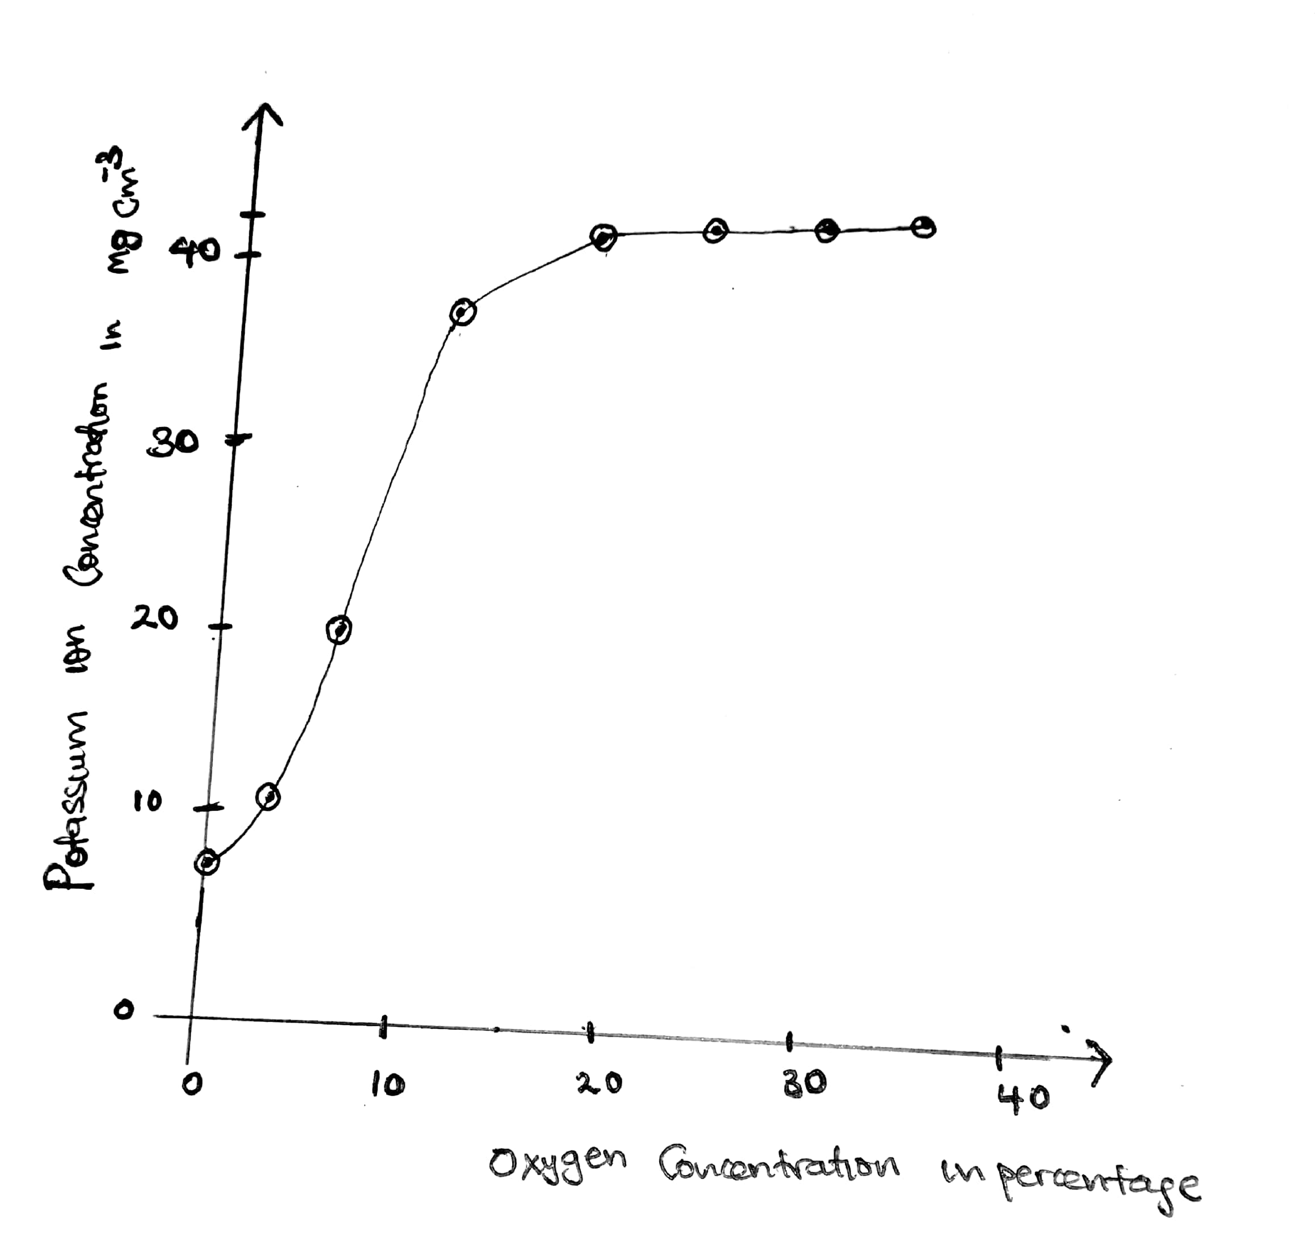
a) Identify the process by which potassium ions are absorbed by the plant roots (01mark)
......................................................................................................................
......................................................................................................................
b) Give an explanation for each of the following

i) Potassium ions are present in roots even at zero concentration of oxygen (02marks)
......................................................................................................................
......................................................................................................................
......................................................................................................................
......................................................................................................................
ii) Potassium ion concentration in roots increase rapidly between 5% to 15% oxygen concentration (02marks)
......................................................................................................................
......................................................................................................................
......................................................................................................................
......................................................................................................................
c) State any one other factor that may affect uptake of potassium ions and explain how it may affect (02marks)
......................................................................................................................
......................................................................................................................
......................................................................................................................
......................................................................................................................
di) Potassium cyanide is a know metabolic poison. Explain how potassium cyanide affect the uptake of potassium ions by the roots (02marks)

......................................................................................................................
......................................................................................................................
ii) Identify the root structures that are responsible for absorption of mineral salts from the ground (01mark)
......................................................................................................................
......................................................................................................................

Section c
Attempt only two questions
4 Describe how the following groups of plants are adapted to survive in their habitats
a) Xerophytes (08marks)
b) Halophytes (05marks)
c) Hydrophytes (02marks)
5a) Distinguish between gutation and transpiration (02marks)
b) Describe how the following forces contribute to the continuous flow of water within a plant
i) Transpiration pull (05marks)
ii) Capillarity (03marks)
iii) Cohesion and adhesion forces (04marks)
6. Describe how the following factors affect the rate of transpiration in a plant
Temperature (04marks)
Humidity (03marks)
b) Describe an experiment to show that transpiration takes place in plants (08marks)
7a) Explain the following observation
i) Water logged soils are deficient in nitrates (03marks)
ii) Terrestrial plants which are water logged slow down the uptake of some minerals (04marks)
b) How are root hairs adapted to perform their functions (08marks)
END

